**STEM Program (Training of Trainers) Monthly report – June 2024**

1. **Major Activities of the month**

* **Preparing Modules of TOT (English is ready, translation in Gujarati is under progress)**
* **Kits have been given to Transpek Trainers**
* **First TOT carried out on 25.06.2024 with Transpek Trainers in order to train them for 6 modules**

1. 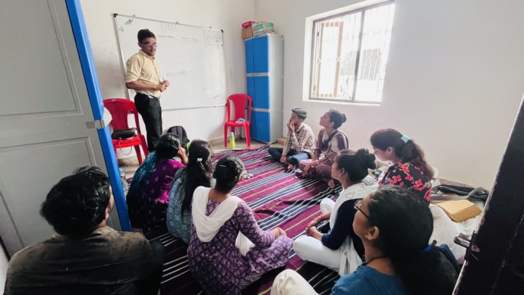**Report of Training of Trainers: STEM program**

**Date:** 25.06.2024  
**Trainer:** Mr. Dhruv Saidava  
**Number of Participants:** 5 (Transpek Teachers)

**Objectives of the Training:**  
The primary objective of the training was to prepare trainers on the STEM modules covered in the program and to ensure they could confidently perform and teach the experiments.

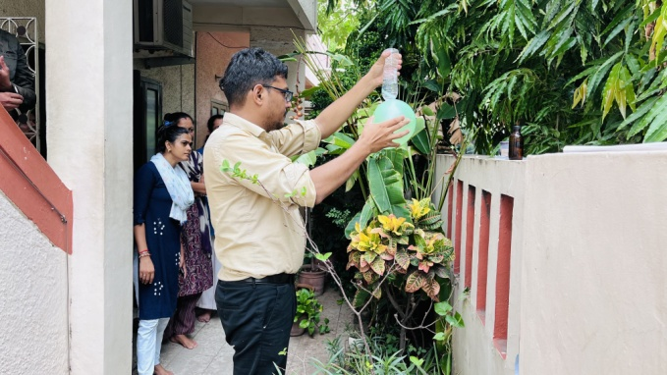**Training Overview:**   
Mr. Dhruv Saidava conducted an interactive and hands-on training session for the trainers. He began by demonstrating each experiment himself, providing clear instructions and explanations. Afterward, the trainers were given the opportunity to perform the experiments themselves, reinforcing their understanding and ability to teach these concepts to students.

**STEM Modules Covered:**   
The training encompassed six modules, each focusing on a different aspect of STEM

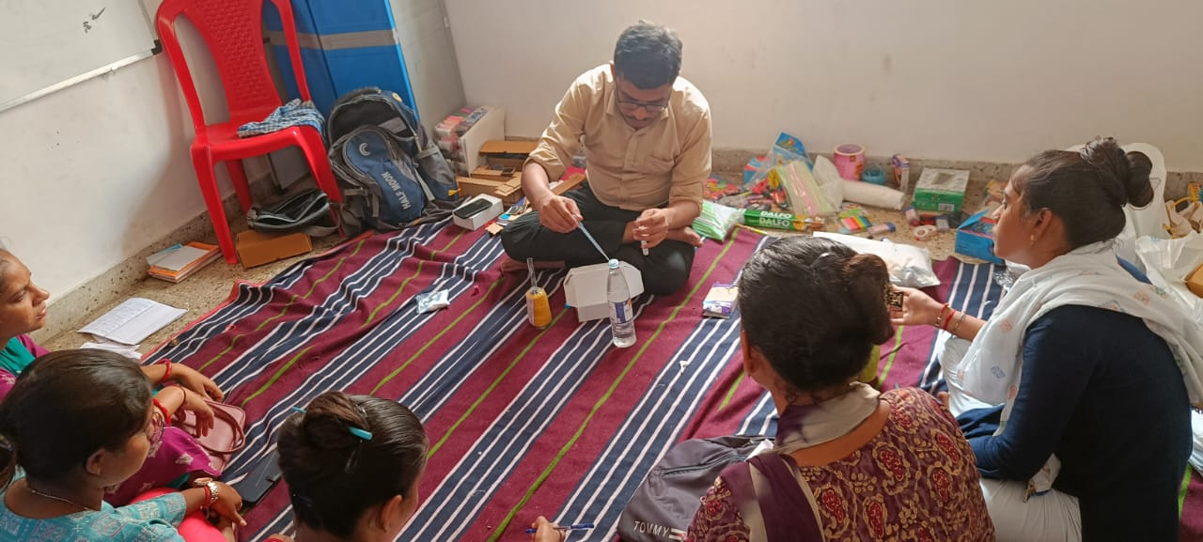education:

1. **Basic Circuits** - Participants learned about electrical circuits, their components, and how to create simple circuits.
2. **Lights and Optics** - This module covered the principles of light, lenses, and optical illusions.
3. **Forces and Pressure** - Trainers explored the concepts of force, pressure, and their applications through various experiments.
4. **Solar Car** - This module involved building and understanding the mechanics of solar-powered cars.
5. **Fun with Chemistry** - Participants engaged in chemical experiments that demonstrated fundamental chemical reactions.
6. **Buoyancy** - This module included experiments with elasticity and bouncing objects to illustrate principles of physics.

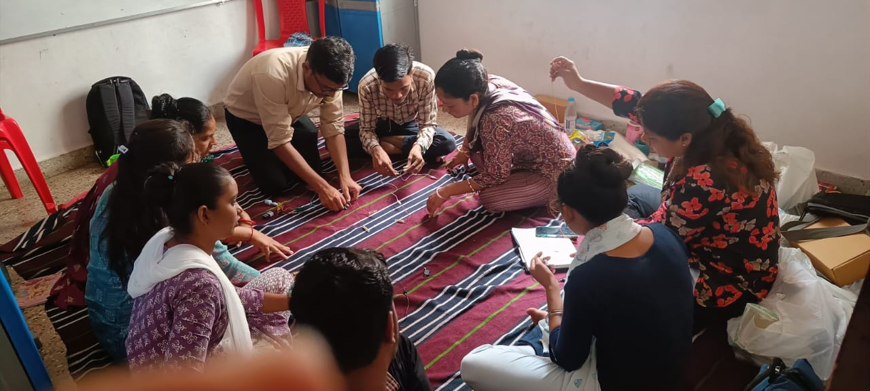**Training Methodology:**

Each experiment was demonstrated by Mr.Saidava, followed by hands-on practice for the trainers. Challenges associated with each module were discussed in detail. Trainers were taught not only how to conduct the experiments but also how to explain the underlying scientific principles to students effectively. The training emphasized interactive and inquiry-based learning to engage students and enhance their understanding of STEM concepts.

**Outcome:**   
The training was successful in equipping the trainers with the necessary skills and knowledge to effectively deliver STEM education. The hands-on approach and the emphasis on practical application ensured that the trainers felt confident in conducting the experiments and teaching the associated concepts. Positive feedback was received from all participants, who appreciated the interactive nature of the training session. Although training was good, trainers will need handholding for execution of program.

